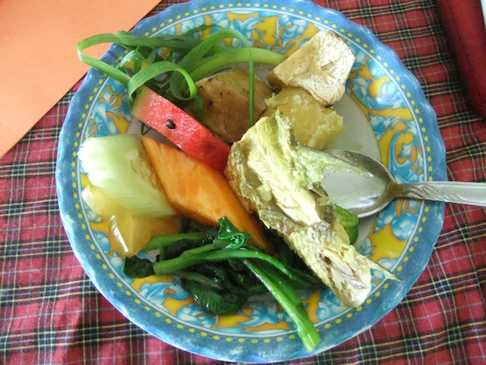

Roselyn Kabu & Yukiko Kasuya

Women and Nutritional Health

Manual for Trainers

Kastom Gaden Association

Women and nutritional health